Continue
Workshop #6
Flutter Developer Bootcamp

Purpose
This workshop demonstrates the use of the continue statement within a for loop.

Problem
In the given workshop defines a main function where a for loop iterates through numbers from 0 to 6. During each iteration, it checks if the current number i equals 3. If true, it prints a message indicating that i is skipped but continues to the next iteration using continue. For all other values of i, it simply prints the value. As a result, when executed, the output will display the numbers from 0 to 6, except for the number 3 which is skipped with the accompanying message. You need to make the number 5 skipped with accompanying message.

How to Solve
- Checkout the workshop from Git Repo:
git clone -b <user-branch> <repo-URL>
- Open the root folder inside VS Code
- Open the root folder in terminal
- Run the command dart run filename.dart
- The Dart program defines a main function where a for loop iterates from 0 to 6.
- During each iteration, it checks if the current value i equals 5 using an if statement.
- If i equals 5, it prints 'Skipped 5 but loop continues' and skips to the next iteration using continue.
- For all other values of i (0, 1, 2, 3, 4, 6), it simply prints the value of i.
- Go To File: <specific-file--method> à <method-name>, implement your logic.

You will Achieve
When you complete this workshop you will learn the following:

Methods and Functions Used:

- Main Function (main):
- Entry point of the Dart program.
- Responsible for starting the execution of the program.
- For Loop:
- Iterates through numbers from 0 to 6 (for (int i = 0; i <= 6; i++)).
- Executes a block of code repeatedly until a specified condition (i <= 6) is no longer true.
- Conditional Check (if statement):
- Checks if the current value of i equals 5 (if (i == 5)).
- Controls whether a block of code is executed based on the condition provided (i == 5).
- Print Function (print()):
- Outputs a message or a value to the console.
- Used to display the current value of i or a specific message when i equals 5 (print('Skipped $i but loop continues')).
- Continue Statement (continue):
- Skips the remaining code in the current iteration of a loop (continue;).
- Causes the loop to proceed to the next iteration without executing the subsequent statements in the loop body for the current iteration.

Screenshots

Before implementation (without making number 5 skipped)

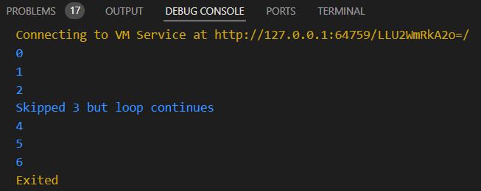

After implementation (with making number 5 skipped)

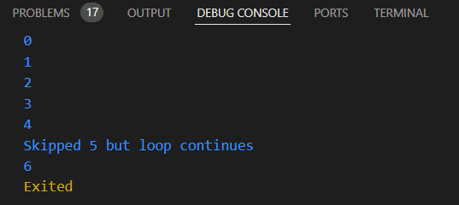

How to submit your workshop
Push your project back to the same git branch using command:
<command name>

Happy Coding!

